UDecide

RISK MANAGEMENT PLAN  
DOCUMENT REFERENCE NUMBER: UD-RMP  
  
DATE: 08.04.2021  
 REVISION NUMBER: 1.0

*AUTHOR:* Sofie Bjørn

*REVIEWER:* Sigrid Stang, Emma Elbo & Amalie Koch

SCOPE: This document contains the plan for the risk management. The analysis in “UD-RM-analysis” uses tables and definitions contained in this document.

REFERENCES: UD-RM-analysis

REVISION HISTORY:

|  |  |  |  |
| --- | --- | --- | --- |
| **Revision** | **Revised by** | **Revision date** | **Description of changes** |
| 1.0 | Sofie Bjørn | 08.04.2021 | First version |
|  |  |  |  |
|  |  |  |  |

APPROVAL:

|  |  |  |  |
| --- | --- | --- | --- |
|  | *Name and job function* | *Signature* | *Date* |
| *Author:* |  | | |
| *Reviewer:* |  | | |
| *Independent reviewer:* |  | | |

Overall plan for risk management

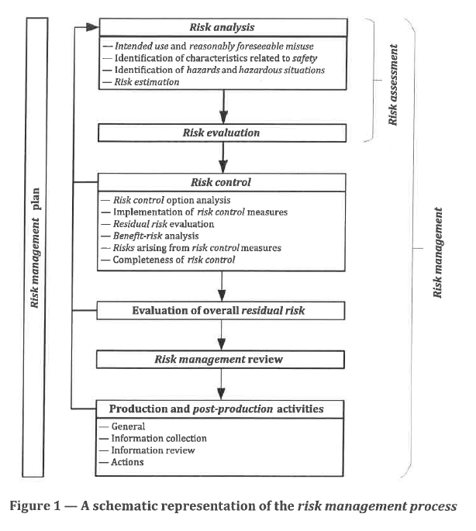

RISK ANALYSIS

Identification of hazards

* List from the ISO14971

RISK EVALUATION AND CONTROL

Quantification of hazards

|  |  |  |  |
| --- | --- | --- | --- |
| Severity level | | Failure description | Manufacturer’s definition |
| Description | Numeric value |
| Catastrophic | 5 | Results in patient’s death | Death |
| Critical | 4 | Results in permanent impairment or life-threatening injury | Irreversible nerve damage.  Cyber-attack. |
| Serious | 3 | Results in impairment requiring professional medical intervention | Reversible nerve damage |
| Minor | 2 | Results in temporary injury or impairment not requiring professional medical intervention | Irritation of the skin |
| Negligible | 1 | Inconvenience or temporary discomfort | Worsening of symptoms or increased impact on quality of life |

Probability of occurence

|  |  |  |
| --- | --- | --- |
| Probability | | Description |
| Description | Numeric value |
| Frequent | 5 | Likely to occur immediately or within a short period (may happen several times in one year) |
| Propable | 4 | Probably will occur (may happen several times in 1 - 2 years) |
| Occasional | 3 | Possible to occur (may happen sometime in 2 to 5 years) |
| Remote | 2 | Unlikely to occur (may happen sometime in 5 - 10 years) |
| Improbable | 1 | Improbable to occur (may happen sometime in 10-15 years) |

Risk acceptance criteria

|  |  |  |  |  |  |
| --- | --- | --- | --- | --- | --- |
| Probability | Severity | | | | |
| Negligible (1) | Minor (2) | Serious (3) | Critical (4) | Catastrophic (5) |
| Frequent (5) | Broadly acceptable (5) | Intolerable  (10) | Intolerable (15) | Intolerable (20) | Intolerable (25) |
| Propable (4) | Broadly acceptable (4) | Intolerable (8) | Intolerable (12) | Intolerable (16) | Intolerable (20) |
| Occisional (3) | Broadly acceptable (3) | Broadly acceptable (6) | Intolerable (9) | Intolerable (12) | Intolerable (15) |
| Remote (2) | Broadly acceptable (2) | Broadly acceptable (4) | Broadly acceptable (6) | Intolerable (8) | Intolerable (10) |
| Improbable (1) | Broadly acceptable (1) | Broadly acceptable (2) | Broadly acceptable (3) | Broadly acceptable (4) | Broadly acceptable (5) |